**MZUMBE UNIVERSITY**



**FACULTY OF SCIENCE AND TECHNOLOGY**

**(FST)**

**PROGRAM NAME: Bsc. ICTM**

**COURSE CODE: CSS 114**

**COURSE NAME: DATABASE AND DATABASE SYSTEMS**

**GROUP NUMBER: GROUP 5**

**LECTURER DR. A. MAGUYA**

**GROUP NAMES:**

|  |  |
| --- | --- |
| **NAMES** | **REGISTRATION NUMBER** |
| JULIANA WILLIARD MARCO | 14320004/T.20 |
| INNOCENT J MARO | 14320013/T.20 |
| SIDDY IDDY SIDDY | 14320011/T.20 |
| NAJMA NUHU HATHA | 14320001/T.20 |
| OMARI S. OMARI | 14320038/T.20 |
| IPYANA E. KALENGE | 14320008/T.20 |
| ENOS LAWI MASHANJARA | 14320041/T.20 |
| ANTHONI LUGOME BEDA | 14320044/T.20 |
| MSAFIRI ALLY | 14320025/T.20 |

**TASK 1: UNIVERSITY ONLINE APPLICATION (EVEN GROUPS < 5)**

Following the decision by the TCU which requires all universities to manage their own admission matters, many universities have decided to invest in online applications systems. These systems are database-driven websites which enable students all over the country (and abroad) to apply for admission. You task is to design a database for a typical online applications system. The database should support: online application, selection, admission, etc

.

**TABLE OF CONTENTS**

**INTRODUCTION** 4

**BUSINESS RULES** 4

**About University Online Application Database(UOADB)** 4

**Physical Schema for the University Online Application Database** 5

**Logical Schema for the University Online Application Database** 6

**Using MySQL Query for the University Online Application Database** 7

**Applicant table** 8

**Programme table** 9

**Education information table** 10

**Application status table** 11

**Next of kin table** 12

**Disability information table** 13

**Contact information table** 14

**Payment table** 15

**Insertion of at Least 25 records in the tables:** 16

# **INTRODUCTION**

## **BUSINESS RULES**

According to our discussion, the following are the business rules we have discussed:

* Application should have a user name
* There should be at least three selections for the admission
* Each applicant must pay
* Each applicant must have Ordinary Level result, AVN Number or Advanced Level result in order to be accepted by the university
* Each applicant should describe the type of sponsorship (either private or government)
* Each applicant should describe his or her next of kin
* Preliminary education information and key should be provided with regard of nationality

Each applicant must have a maximum number of one account

## **About University Online Application Database(UOADB)**

The database designed to work at the university online application database to solve some of problems and simplify the process of local and abroad application of particular university. We named database UOADB, the database has the following tables,

1. program
2. application status
3. applicant
4. payment
5. next of kin
6. education information
7. disability
8. contact information

# **Physical Schema for the University Online Application Database**

The following is the physical schema the university online application database:

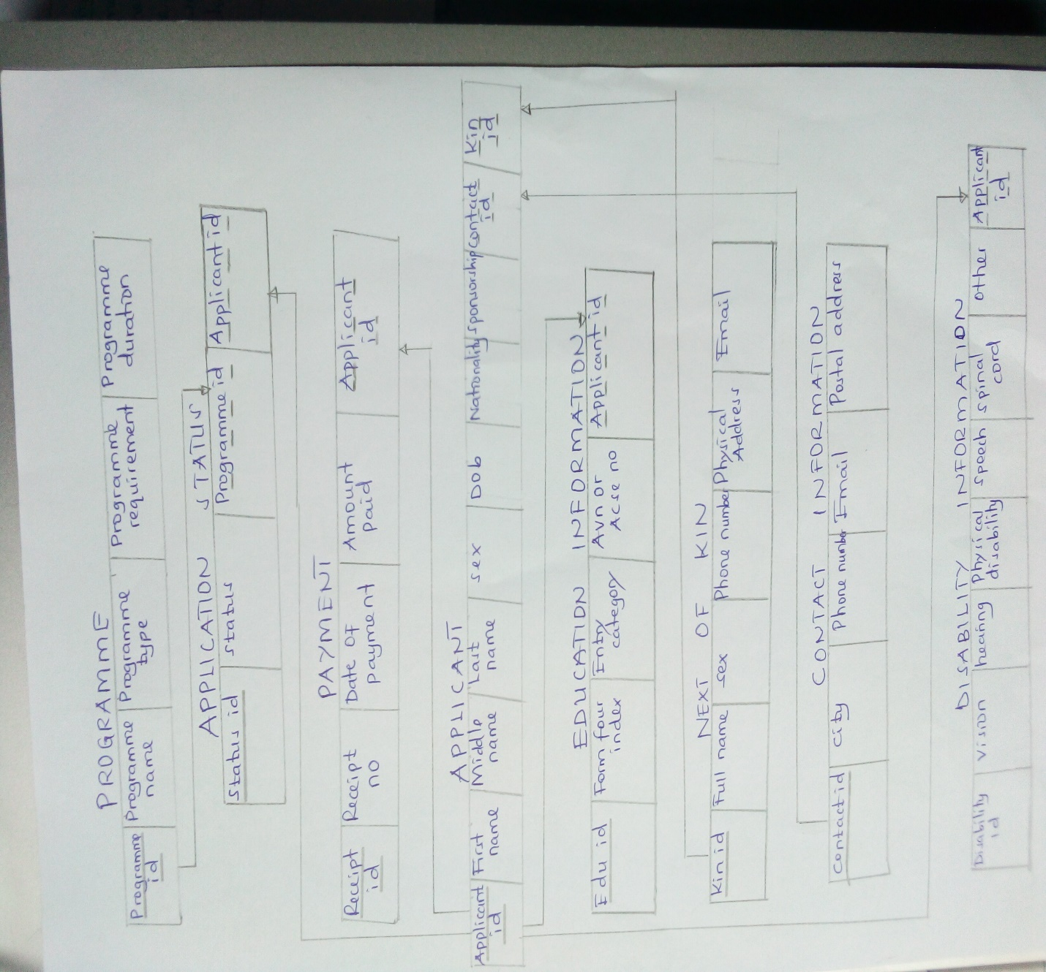

# **Logical Schema for the University Online Application Database**

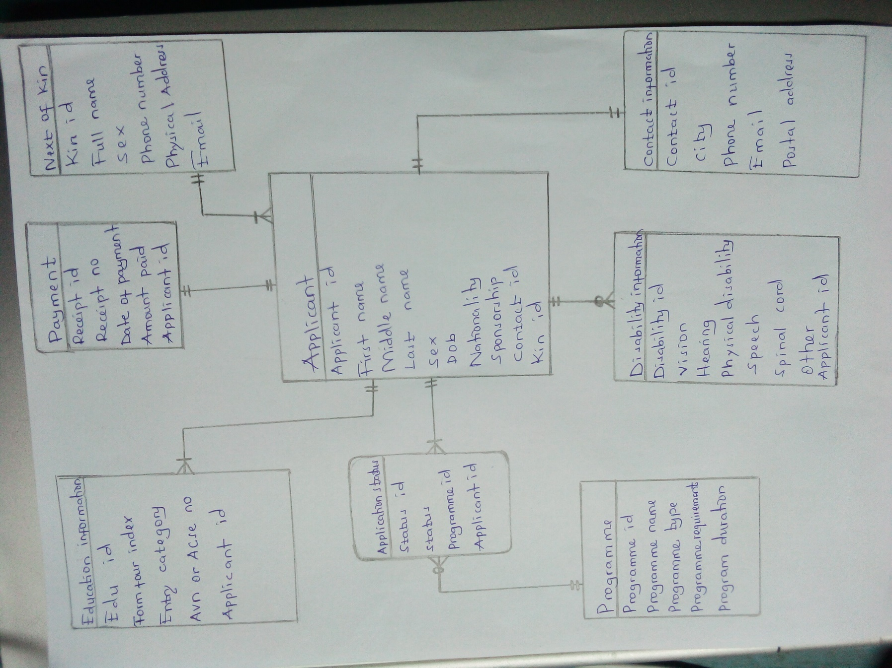

# **Using MySQL Query for the University Online Application Database**

Tables created for the database uoadb:

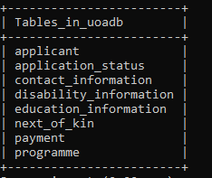

## **Applicant table**

The table of applicant that holds the following applicant attributes:

applicant_id, firstName, middleName, LastName, sex, dob, nationality, sponsorship, contact_id and kin_id.

The following is the screenshot for applicant table.

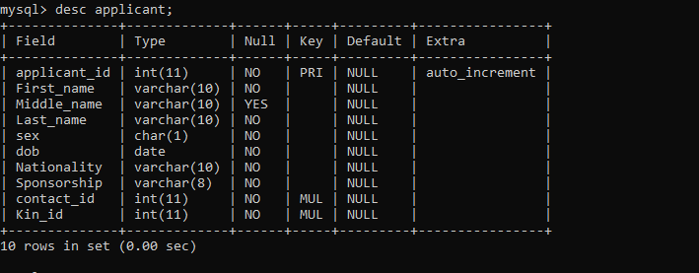

## **Programme table**

The programme table allows to holds the following attributes:

program_id, programme_name, programme_type, programme_requirement and programme_duration.

The following is the screenshot for applicant table

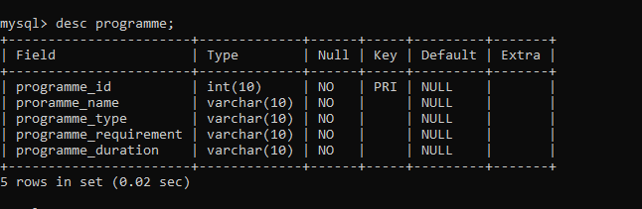

## **Education information table**

The education information tables that holds attributes as follows:

edu_id, form_four_index, entry_category, avn_or_acsee_no and applicant_id.

The following is the screenshot for applicant table

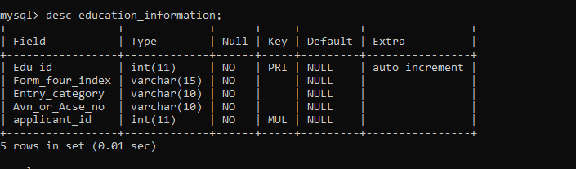

## **Application status table**

The application status table is a table that holds the following attributes:

status_id, status, programme_id and applicant_id

The following is the screenshot for applicant table 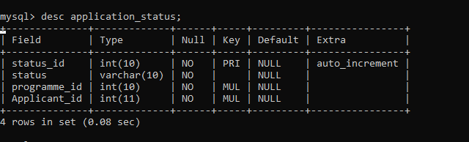

## **Next of kin table**

The Next of kin is the table that contains attributes as follows:

kin_id, firstName, middleName, lastName, sex, phone_number, physical_address and email.

The following is the screenshot for applicant table

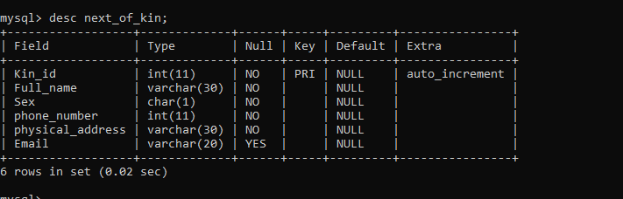

## **Disability information table**

This tables contains the following attributes

diability_id, vision, hearing, physical_mobility, speech, spinal_cord, other and applicant_id.

The following is the screenshot for applicant table

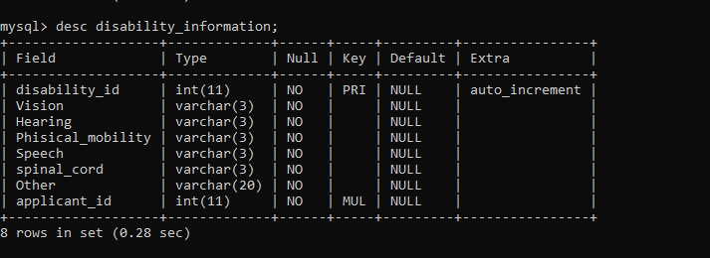

## **Contact information table**

This table contains the following attributes.

contact_id, city, phone_number, email and postal_address

The following is the screenshot for applicant table.

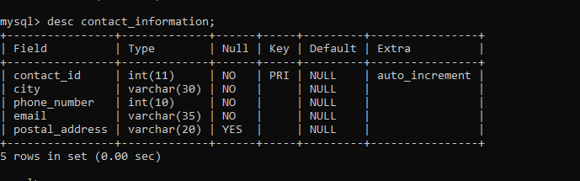

## **Payment table**

This table contains the following attributes

receipt_id, receipt_no, date_of_payment, amount_paid and applicant_id.

The following is the screenshot for applicant table.

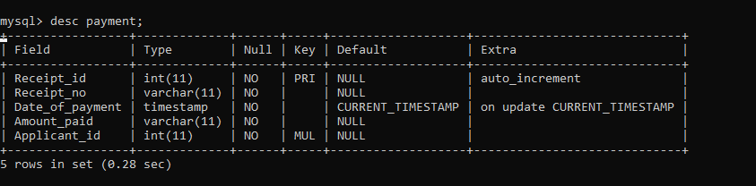

# **Insertion of at Least 25 records in the tables:**

INSERT INTO Next_of_kin value

(not NULL,'iddy siddy','M','0768984536','kibaha, Pwani','erasto@gmail.com'),

(not NULL,'juma kaseja','M','0768985536','Ulanga,Morogoro','kaseja@gmail.com'),

(not NULL,'Mariam bichau','F','0768930946','Kwa mpalange, Dar Es Salaam','bichau@gmail.com'),

(not null,'kishikwambi chaudele','F','0854673372','Madongo kuinama, Dar Es Salaam','kishikwambi@yahoo.com'),

(not null,'rehema Storo','F','0345562893','Handeni, Tanga','rstoro@hotmail.com'),

(not NULL,'imani sahili','M','0710884536','kigongo, Mwanza','sahili@hotmail.com'),

(not null,'salma khamisi','F','0754984536','chamwino, Dodoma','salma@gmail.com'),

(not null,'songolo maridadi','M','0774000536','mkwawa, Iringa','songolo@gmail.com'),

(not null,'juma mabata','M','0786984777','Kilombero, Morogoro','mabata@yahoo.com'),

(not null,'twende kilioni','M','078000777','Uyole, Mbeya','tanokichwa@yahoo.com'),

(not NULL,'mbogo mkula','M','0778598576','Mzumbe Morogoro','aggy@gmail.com'),

(not null,'juma mgunda','M','0693435657','Temeke, Dar Es Salaam','mgunda@yahoo.com'),

(not null,'fahami jumaa','M','0789546372','Ilala, Dar Es Salaam','fahami@hotmail.com'),

(not null,'ahmada chapombe','M','0774980046','kibaigwa, Dodoma','ahmada@gmail.com'),

(not null,'kibena mwinyimbegu','F','0754864536','chamwino, Morogoro','mwinyimbegu@gmail.com'),

(not null,'rahma kassim','F','066684536','Kibada, Dar Es Salaam','raykassim@gmail.com'),

(not null,'mzee mpili','M','0754987536','Ikwiriri, Pwani','mpili@gmail.com'),

(not null,'choneke gabwe','M','0739984536','msangakumweli, Pwani','gabwe@gmail.com'),

(not null, 'hombo dikolelamunyu', 'M', '0717895453', 'kisaki, Morogoro', 'dikolela9@gmail.com'),

(not null,'madizo zozeni','F','0728984536','furahisha, Mwanza','zozeni@gmail.com'),

(not null,'john mkwawa','M','0754928536','ilula Iringa','chandoma@gmail.com'),

(not null,'Edgar Chirry','M','0711984536','Mombasa','chirrye6124@gmail.co.ke'),

(not null,'Laurent Madjizi','M','0728484730','Mambo, Tanga','madjilau@gmail.com'),

(not null,'Kopa Kabana','M','0749984566','Old Moshi, Kilimanjaro','kopakabana@yahoo.com'),

(not null,'Krezi Kapcha','M','0728984536','furahisha, Mwanza','zozeni@gmail.com');

INSERT INTO contact_information value

(not null,'Morogoro','0654678790','siddy@gmail.com','2345 P.O BOX MOROGORO'),

(not null,'Dar Es Salaam','0654000690','irene@gmail.com','23 P.O BOX DAR ES SALAAM'),

(not null,'Iringa','0654675090','lakuchumpa@gmail.com','45 P.O BOX IRINGA' ),

(not null,'Tanga','0654611113','shangiliasimba@gmail.com','345 P.O BOX TANGA' ),

(not null,'Morogoro','0764839083','sangara@gmail.com','25 P.O BOX MOROGORO' ),

(not null,'Mwanza','0775096571','chakorii@gmail.com','34 P.O BOX MWANZA' ),

(not null,'Dodoma','0873190249','dadavanny@gmail.com','987 P.O BOX DODOMA' ),

(not null,'Arusha','0765906482','sambasoti@gmail.com','098 P.O BOX ARUSHA' ),

(not null,'Moshi','0654999970','chilunda@gmail.com','205 P.O BOX MOSHI' ),

(not null,'Bukoba','0695768523','njapuri@hotmail.com','421 P.O BOX BUKOBA' ),

(not null,'Mtwara','0624567290','chondechonde@gmail.com','119 P.O BOX MTWARA' ),

(not null,'Mbeya','0765489334','chakuchaku@gmail.com','1032 P.O BOX MBEYA'),

(not null,'Singida','0765000334','chakubanga@gmail.com','132 P.O BOX SINGIDA'),

(not null,'Morogoro','0799989334','chakochoko@gmail.com','1322 P.O BOX MOROGORO'),

(not null,'Arusha','0788889334','kunguru@gmail.com','6832 P.O BOX ARUSHA'),

(not null,'Tanga','0777889390','gebo1967@gmail.com','2680 P.O BOX TANGA'),

(not null,'Arusha','0666689334','machaku@gmail.com','7092 P.O BOX ARUSHA'),

(not null,'Morogoro','0453289334','kangakanga@gmail.com','6234 P.O BOX MOROGORO'),

(not null,'Tabora','0704589334','bingiribayoyo@gmail.com','2341 P.O BOX TABORA'),

(not null,'Rukwa','0765559334','kasemetena@gmail.com','653 P.O BOX RUKWA'),

(not null,'Kigoma','0744489334','mzeejongo@gmail.com','934 P.O BOX KIGOMA'),

(not null,'Mombasa','0711768594','kunoga@gmail.com','5646 P.O BOX KENYA'),

(not null,'Dar es Salaam','0623768594','petropaul210@gmail.com','1212 P.O BOX DAR ES SALAAM'),

(not null,'Dar es Salaam','0623768594','pasikaratasi89@gmail.com','789 P.O BOX DAR ES SALAAM'),

(not null,'Tanga','0623768594','funayoizkat29@gmail.com','5788 P.O BOX TANGA');

INSERT INTO applicant value

(not null,'siddy','iddy','siddy','M','2000-06-15','Tanzania','HESLB',1,1),

(not null,'kalunde','matambala','kadamse','F','2001-02-14','Burundi','PRIVATE',3,4),

(not null,'love','','msambwanda','F','2000-01-30','Rwanda','PRIVATE',4,3),

(not null,'mashalove','don','dada','F','1999-06-16','Uganda','PRIVATE',7,9),

(not null,'nyaranda','faranga','magego','F','1998-03-29','Msumbiji','PRIVATE',6,5),

(not null,'paul','r','kagame','M','1998-04-12','Rwanda','PRIVATE',5,7),

(not null,'rukia','A','Mapunda','F','2002-03-17','Tanzania','HESLB',8,6),

(not null,'saipha','M','Njaite','F','2001-06-16','Tanzania','HESLB',9,8),

(not null,'Safia','H','Msiku','F','2001-04-30','Tanzania','HESLB',11,10),

(not null,'juma','gamba','jackson','M','2000-05-21','Tanzania','PRIVATE',10,11),

(not null,'kishundundu','duduma','changala','F','2001-02-24','Burundi','PRIVATE',12,12),

(not null,'lakuchumpa','','lakumparama','M','2001-07-25','Tanzania','HESLB',2,2),

(not null,'Jeje','','Jeje','M','2000-12-23','Tanzania','PRIVATE',13,13),

(not null,'Abdallah','sahim','juma','M','1999-10-29','Tanzania','PRIVATE',14,14),

(not null,'sasha','abdulratifu','ally','F','2000-12-21','Tanzania','HESLB',15,15),

(not null,'rayuu','ahmed','shabiby','F','2001-08-19','Tanzania','HESLB',16,16),

(not null,'Juma','K','Mpili','M','1997-08-2','Tanzania','PRIVATE',17,17),

(not null,'Laurine','','Chirry','F','1997-09-11','Kenya','PRIVATE',22,22),

(not null,'Kabanga','Ahmed','Gabwe','M','1999-01-01','Tanzania','PRIVATE',18,18),

(not null,'Rafael','Hombo','Dikolelamunyu','M','2000-03-8','Tanzania','PRIVATE',19,19),

(not null,'Cefa','M','Zozeni','F','1999-11-21','Tanzania','PRIVATE',20,20),

(not null,'Christina','Kalolo','Mkwawa','F','2000-04-19','Tanzania','HESLB',21,21),

(not null,'Dortmund','B','Madjizi','M','2000-12-25','Tanzania','PRIVATE',23,23),

(not null,'Beka','Kopa','Kabana','M','1997-03-28','Tanzania','PRIVATE',24,24),

(not null,'Mackie','K','Kapcha','F','1995-03-22','Tanzania','PRIVATE',25,25);

INSERT INTO disability_information value

(not null,'NO','NO','YES','YES','NO','NO','2'),

(not null,'NO','NO','NO','NO','NO','NO','3'),

(not null,'NO','NO','NO','NO','NO','NO','4'),

(not null,'NO','YES','NO','YES','NO','NO','6'),

(not null,'NO','NO','NO','NO','NO','NO','5'),

(not null,'YES','NO','NO','NO','YES','NO','7'),

(not null,'NO','NO','NO','NO','YES','NO','9'),

(not null,'NO','NO','NO','NO','NO','NO','8'),

(not null,'NO','NO','NO','NO','NO','NO','10'),

(not null,'NO','NO','NO','NO','NO','NO','11'),

(not null,'NO','NO','NO','NO','NO','NO','12'),

(not null,'NO','NO','NO','NO','NO','NO','1'),

(not null,'NO','NO','NO','NO','NO','NO','13'),

(not null,'NO','NO','NO','NO','NO','NO','14'),

(not null,'NO','NO','NO','NO','NO','NO','15'),

(not null,'NO','NO','NO','NO','NO','NO','16'),

(not null,'NO','NO','NO','NO','NO','NO','17'),

(not null,'NO','NO','NO','NO','NO','NO','18'),

(not null,'NO','NO','NO','NO','NO','NO','19'),

(not null,'NO','NO','NO','NO','NO','NO','20'),

(not null,'NO','NO','NO','NO','NO','NO','21'),

(not null,'NO','NO','NO','NO','NO','NO','22'),

(not null,'NO','NO','NO','NO','NO','NO','23'),

(not null,'NO','NO','NO','NO','NO','NO','24'),

(not null,'NO','NO','NO','NO','NO','NO','25');

INSERT INTO education_information value

(not null,'S0332.0123.2017','EQUIVALENT','12324576KE66',2),

(not null,'S1332.0197.2018','EQUIVALENT','12004576KE66',3),

(not null,'S0332.0123.2018','DIRECT','S2471.0267.2021',5),

(not null,'S0032.0023.2017','EQUIVALENT','12356576KE66',4),

(not null,'S1723.0167.2016','EQUIVALENT','14658I78ME54',10),

(not null,'S0359.0024.2015','DIRECT','S0745.0567.2020',6),

(NOT NULL,'S0456.0167.2016','DIRECT','S0359.0511.2019',7),

(NOT NULL,'S0123.0009.2016','EQUIVALENT','145764854KE98',12),

(not null,'S3201.0189.2015','DIRECT','S0578.0677.2020',8),

(NOT null,'S2021.0252.2016','DIRECT','S1278.0771.2020',9),

(not NULL,'S0349.0456.2014','EQUIVALENT','S0452.0516.2021',11),

(not null,'S3576.0070.2019','DIRECT','S0452.0511.2021',1),

(not null,'S0335.0456.2018','DIRECT','S4025.1610.2020',13),

(not null,'S3296.1435.2017','DIRECT','S0452.0511.2021',14),

(not null,'S3506.0659.2019','DIRECT','S0452.0511.2021',15),

(not null,'S3571.0005.2017','DIRECT','S0452.0511.2021',16),

(not null,'S1570.0074.2014','DIRECT','S0452.0511.2021',17),

(not NULL,'K0349.0356.2012','EQUIVALENT','12356666KE77',18),

(not null,'S1723.0167.2016','EQUIVALENT','14108678ME78',19),

(not null,'S1723.0167.2016','EQUIVALENT','18658978ME54',20),

(not null,'S0556.0332.2016','DIRECT','S0452.0511.2021',21),

(not null,'S3070.2435.2017','DIRECT','S0452.0511.2021',22),

(not null,'S0576.0098.2017','DIRECT','S0452.0511.2021',23),

(not null,'S3006.1234.2014','DIRECT','S0452.0511.2021',24),

(not null,'S3376.0985.2012','EQUIVALENT','12350066KE33',25);

INSERT INTO payment value

(not null,'EC20670989547',now(),'10,000',2),

(not null,'EF206765348957',now(),'10,000',3),

(not null,'EC209089689547',now(),'10,000',4),

(not null,'EC206709895457',now(),'10,000',5),

(not null,'EC206435989547',now(),'10,000',6),

(not null,'EF206732489547',now(),'10,000',7),

(not null,'EF206132894547',now(),'10,000',8),

(not null,'EC211109895447',now(),'10,000',10),

(not null,'EH208900859547',now(),'10,000',9),

(not null,'EC20670456547',now(),'10,000',11),

(not null,'EC20623989547',now(),'10,000',12),

(not null,'EH25564307689',now(),'10,000',1),

(not null,'EF13368929624',now(),'10,000',13),

(not null,'EF23562907656',now(),'10,000',14),

(not null,'EF21562229076',now(),'10,000',15),

(not null,'EF25564307786',now(),'10,000',16),

(not null,'EC12562903356',now(),'10,000',17),

(not null,'EH21562990126',now(),'10,000',18),

(not null,'EF12968907376',now(),'10,000',19),

(not null,'EC12959902056',now(),'10,000',20),

(not null,'EF13562907656',now(),'10,000',21),

(not null,'EF25535907359',now(),'10,000',22),

(not null,'EF21562928965',now(),'10,000',23),

(not null,'EH17492939656',now(),'10,000',24),

(not null,'EC21562015079',now(),'10,000',25);

INSERT INTO programme value

(not null,'BScICTM','Bachelor','Two principal passes (4 points) science subject OR Diploma in related programme a minimum GPA of 3.0','3 Years'),

(not null,'BScICTB','Bachelor','Two principal passes (4 points) science subject OR Diploma in related programme a minimum GPA of 3.0','3 Years'),

(not null,'MICT-EDU','Bachelor','Two principal passes (4 points) science subject OR Diploma in related programme a minimum GPA of 3.0','3 Years'),

(not null,'BScAS','Bachelor','Two principal passes (4 points) science subject OR Diploma in related programme a minimum GPA of 3.0','3 Years'),

(not null,'BScIEM','Bachelor','Two principal passes (4 points) science subject OR Diploma in related programme a minimum GPA of 3.0','3 Years'),

(not null,'BScITS','Bachelor','Two principal passes (4 points) science subject OR Diploma in related programme a minimum GPA of 3.0','3 Years'),

(not null,'BPA-RAM','Bachelor','Two principal passes (4 points) OR a minimum GPA of 3.0','3 Years'),

(not null,'BHSM','Bachelor','Two principal passes (4 points) OR a minimum GPA of 3.0','3 Years'),

(not null,'BHRM','Bachelor','Two principal passes (4 points) OR a minimum GPA of 3.0','3 Years'),

(not null,'BPA-RAM','Bachelor','Two principal passes (4 points) OR a minimum GPA of 3.0','3 Years'),

(not null,'BLGM','Bachelor','Two principal passes (4 points) OR a minimum GPA of 3.0','3 Years');

INSERT INTO application_status value

(not null,'SELECTED',1,1),

(not null,'SELECTED',1,2),

(not null,'SELECTED',1,3),

(not null,'SELECTED',2,4),

(not null,'SELECTED',4,5),

(not null,'SELECTED',7,6),

(not null,'SELECTED',6,7),

(not null,'SELECTED',1,8),

(not null,'SELECTED',2,9),

(not null,'SELECTED',6,10),

(not null,'SELECTED',6,11),

(not null,'SELECTED',6,12),

(not null,'SELECTED',11,13),

(not null,'SELECTED',7,14),

(not null,'SELECTED',1,15),

(not null,'SELECTED',3,16),

(not null,'SELECTED',10,17),

(not null,'SELECTED',10,18),

(not null,'SELECTED',11,19),

(not null,'SELECTED',8,20),

(not null,'SELECTED',7,21),

(not null,'SELECTED',2,22),

(not null,'SELECTED',5,23),

(not null,'SELECTED',4,24),

(not null,'SELECTED',4,25);